DATABASE MANAGEMENT SYSTEM PROJECT SYNOPSIS

**1 Title**

Railway Reservation System.

**2 Team Information**

**2.1 Team Leader**

**2.2 Team Members**

Ayush Singla(Roll Number:-2010991512)

Aryan Dev Shourie(Roll Number:-2010991496)

Bhavesh Vaidya(Roll Number:-2010991517)

**3 Introduction**

The railway network of our country is one of the most complex public establishments. We can design a database solution for this network and make the management of the same more natural.

Railways stretches its hands in conducting activities like business, sightseeing, pilgrimage along with transportation of goods. It is easier for long-distance travel. It plays a vital role in national integration. It strengthens the development of the industry and agriculture.

**4 Objective**

1. To prevent a moving train from getting into contact with another train or obstruction and thus to provide**safety to the passengers**, the staff and the rolling stock.

2. To maintain a **safe distance** between two trains on the same line in the same direction to **avoid accidents**.

3. To provide protection against trains **collision** and **derailment** at converging junctions and to give a directional indication at diverging junctions.

4. To provide facilities for safely and efficiently carrying out **shunting operations** in marshalling yards.

5. To allow trains to run at a limited speed while **maintaining** and **repairing** the track.

6. To facilitate the flow of traffic and to increase the carrying capacity of the track.

7. Signalling provides a safe and secure facility to regulate the**arrival**and **departure** of trains from the station.

8. To provide facilities for the **efficient movement of trains** and maximum utility of the rail track.

**5 Technical Specifications**

* Station names
* Tracks that connect those stations (to keep things simple, you can assume that only one track runs between two stations)
* Train IDs with names
* Schedules of the trains

The train schedules will have information on the stations from where the train starts and by when it reaches the destination. It will also include information on which stations it passes through during its journey.

**6 Feasibility Study**

A **feasibility study** is an assessment of the practicality of a proposed project or system. A feasibility study aims to objectively and rationally uncover the strengths and weaknesses of an existing business or proposed venture, opportunities and threats present in the natural environment, the resources required to carry through, and ultimately the prospects for success. In its simplest terms, the two criteria to judge feasibility are cost required and value to be attained.

**7 ER Diagram**

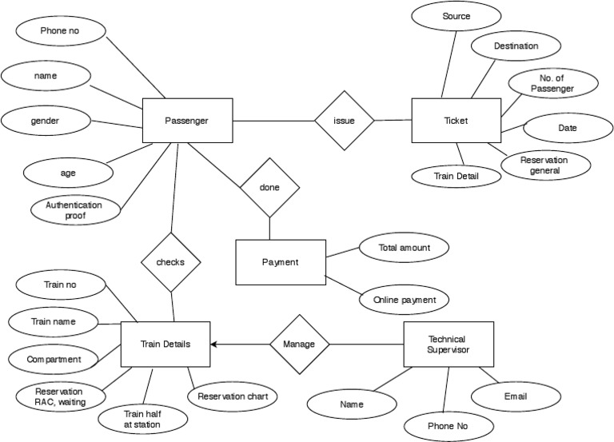

**8 Summary**

This Database is helpful for the applications which facilitate passengers to book the train tickets and check the details of trains and their status from their place itself. It avoids inconveniences of going to the Railway Station for each and every query they get.